**YASH SARANG**

**D6AD**

**47**

**DLCOA / Experiment 8**

-------------------------------------------------------------------------------------------------------------------

**Aim:**

To write a C program for implementation of Restoring Division

-------------------------------------------------------------------------------------------------------------------

**Software:**

Turbo C IDE

-------------------------------------------------------------------------------------------------------------------

**Theory:**

In restoring division algorithm, the dividend is restored after each subtraction operation.

-------------------------------------------------------------------------------------------------------------------

**Algorithm:-**

* Shift A and Q left by 1 position
* Perform A←A – B
* If sign bit of A = 1 then,

Restore A as: A← A +B

Q0 = 0

* If sign bit of A = 0 then

Q0 = 1

* Repeat above steps till all the bits of the dividend are used.

-------------------------------------------------------------------------------------------------------------------

**FLOWCHART**

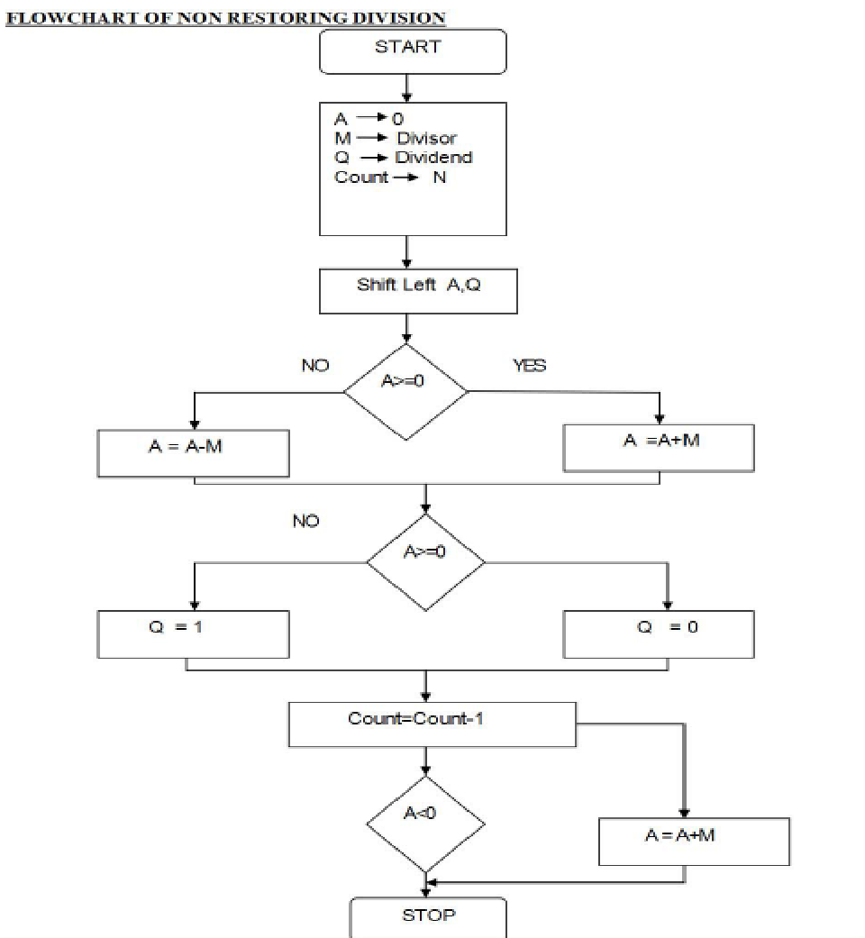

-------------------------------------------------------------------------------------------------------------------

**Program:**

#include <stdio.h>

#include <conio.h>

#include <math.h>

int getsize(int x) {

int c;

if (x <= 1)

c = 2;

else if (x < 4)

c = 2;

else if (x < 8)

c = 3;

else if (x < 16)

c = 4;

else if (x < 32)

c = 5;

else if (x < 64)

c = 6;

else if (x < 128)

c = 7;

else if (x < 256)

c = 8;

else if (x < 512)

c = 9;

return c;

}

int max(int x, int y) {

if (x < y)

return (y);

else

return (x);

}

void main() {

int B, Q, Z, M, c, c1, e, f, g, h, i, j, x, y, ch, in , S, G, P;

int a[24], b[12], b1[12], q[12], carry = 0, count = 0;

long num;

printf("\n\nENTER DIVIDEND\t: ");

scanf("%d", & Q);

y = getsize(Q);

printf("ENTER DIVISOR\t: ");

scanf("%d", & M);

x = getsize(M);

Z = max(x, y);

printf("\n\tTOTAL BITS CONSIDERED FOR RESULT => %d", 2 * Z + 1);

printf("\n\tINITiALLY A IS RESET TO ZERO:");

for (i = 0; i <= Z; i++)

printf("%d ", a[i] = 0);

for (i = Z; i >= 0; i--) {

b1[i] = b[i] = M % 2;

M = M / 2;

b1[i] = 1 - b1[i];

}

carry = 1;

for (i = Z; i >= 0; i--) {

c1 = b1[i] ^ carry;

carry = b1[i] && carry;

b1[i] = c1;

}

for (i = 2 * Z; i > Z; i--) {

a[i] = Q % 2;

Q = Q / 2;

}

printf("\n\n\tDivisor\t\t(M)\t: ");

for (i = 0; i <= Z; i++)

printf("%d ", b[i]);

printf("\n\t2'C Divisor\t(M)\t: ");

for (i = 0; i <= Z; i++)

printf("%d ", b1[i]);

printf("\n\tDividend\t(Q)\t: ");

for (i = Z + 1; i <= 2 * Z; i++)

printf("%d ", a[i]);

printf("\n\n\tBITS CONSIDERED:[ A ] [ M ]");

printf("\n\t\t\t");

for (i = 0; i <= Z; i++)

printf("%d ", a[i]);

printf(" ");

for (i = Z + 1; i <= 2 * Z; i++)

printf("%d ", a[i]);

count = Z;

do {

for (i = 0; i < 2 * Z; i++)

a[i] = a[i + 1];

printf("\n\nLeft Shift\t\t");

for (i = 0; i <= Z; i++)

printf("%d ", a[i]);

printf(" ");

for (i = Z + 1; i < 2 * Z; i++)

printf("%d ", a[i]);

carry = 0;

for (i = Z; i >= 0; i--) {

S = a[i] ^ (b1[i] ^ carry);

G = a[i] && b1[i];

P = a[i] ^ b1[i];

carry = G || (P && carry);

a[i] = S;

}

printf("\nA< -A-M \t\t");

for (i = 0; i <= Z; i++)

printf("%d ", a[i]);

printf(" ");

for (i = Z + 1; i < 2 * Z; i++)

printf("%d ", a[i]);

ch = a[0];

printf("\nBIT Q:%d", ch);

switch (ch) {

case 0:

a[2 * Z] = 1;

printf(" Q0< -1\t\t");

for (i = 0; i <= Z; i++)

printf("%d ", a[i]);

printf(" ");

for (i = Z + 1; i <= 2 * Z; i++)

printf("%d ", a[i]);

break;

case 1:

a[2 * Z] = 0;

printf(" Q0< -0\t\t");

for (i = 0; i <= Z; i++)

printf("%d ", a[i]);

printf(" ");

for (i = Z + 1; i < 2 * Z; i++)

printf("%d ", a[i]);

carry = 0;

for (i = Z; i >= 0; i--) {

S = a[i] ^ (b[i] ^ carry);

G = a[i] && b[i];

P = a[i] ^ b[i];

carry = G || (P && carry);

a[i] = S;

}

printf("\nA< -A+M");

printf("\t\t\t");

for (i = 0; i <= Z; i++)

printf("%d ", a[i]);

printf(" ");

for (i = Z + 1; i <= 2 * Z; i++)

printf("%d ", a[i]);

break;

}

count--;

} while (count != 0);

num = 0;

printf("\n\t\t< < QUOTIENT IN BITS>> :");

for (i = Z + 1; i <= 2 * Z; i++) {

printf("%d ", a[i]);

num = num + pow(2, 2 * Z - i) * a[i];

}

printf("\n\t\tOUOTIENT IN DECIMAL :%d", num);

num = 0;

printf("\n\t\t< < REMAINDER IN BITS>>:");

for (i = 0; i <= Z; i++) {

printf("%d ", a[i]);

num = num + pow(2, Z - i) * a[i];

}

printf("\n\t\tREMAINDER IN DECIMAL :%d", num);

}

-------------------------------------------------------------------------------------------------------------------

**Conclusion:**

We learnt about restoring division algorithm and implemented it using C program.

-------------------------------------------------------------------------------------------------------------------

**Output:**



